
My Target:
____ /25 or _____% Complete on the day of the test.   (Circle when your test is handed back)

Assessment 3: Depth Study 1 –
In-Class Short Answer Responses: (7.5%)
Name: ___________________ Teacher: ____________________

READING TIME – 5 Minutes WORKING TIME – 25 Minutes

Instructions:

____ / 25
- Attempt all questions
- No talking – raise your hand to ask a question.
- No books or notes
- Make sure you write your name at the top and also set a target.

- Outline two sources which historians use to investigate history. Provide an example for each source relevant to your ancient civilisation to support your response.
(4 marks)

- ________________________________________________________________________

_____________________________________________________________________________

_____________________________________________________________________________

_____________________________________________________________________________

- ________________________________________________________________________

_____________________________________________________________________________

_____________________________________________________________________________

_____________________________________________________________________________

- Explain one method an archaeologist would use to investigate history. Provide specific examples to support your response.
(3 marks)
_____________________________________________________________________________

_____________________________________________________________________________

_____________________________________________________________________________

_____________________________________________________________________________

_____________________________________________________________________________

_____________________________________________________________________________

_____________________________________________________________________________

- Explain what is meant by an archaeological site and provide one example of an archaeological site. (3 marks)

____________________________________________________________________________

_____________________________________________________________________________

_____________________________________________________________________________

_____________________________________________________________________________

_____________________________________________________________________________

_____________________________________________________________________________

_____________________________________________________________________________

_____________________________________________________________________________

- Define the term ‘conservation’ and provide an example which relates to history. (3 marks)

Note: Please make sure you link your example to the definition you have provided.

_____________________________________________________________________________

_____________________________________________________________________________

_____________________________________________________________________________

_____________________________________________________________________________

_____________________________________________________________________________

_____________________________________________________________________________

_____________________________________________________________________________

- List two examples of written sources that could be used for an historical investigation.
(2 marks)

- ________________________________________________________________________

- ________________________________________________________________________

- List two examples of heritage sites within Australia. (2 marks)

- ________________________________________________________________________

- ________________________________________________________________________

- Which century were the following years in? (3 marks)

- 1066 AD _____________________________________

- 1999 AD ______________________________________

- 1666 BC ______________________________________

- Using Source 1, complete the following questions below. You need to use the timeline in Source 1.

- The timeline in Source 1 is divided into equal segments.

State how many years each segment represents. _________________________ (1 mark)

- State approximately how many years are represented on the timeline in Source 1?

______________________________ (1 mark)

- State what element of a timeline is missing from Source 1
______________________________ (1mark)

- Explain why timelines need to have a scale. (2 marks)

_____________________________________________________________________________

_____________________________________________________________________________

_____________________________________________________________________________

_____________________________________________________________________________

_____________________________________________________________________________

_____________________________________________________________________________

End of test paper

Source 1

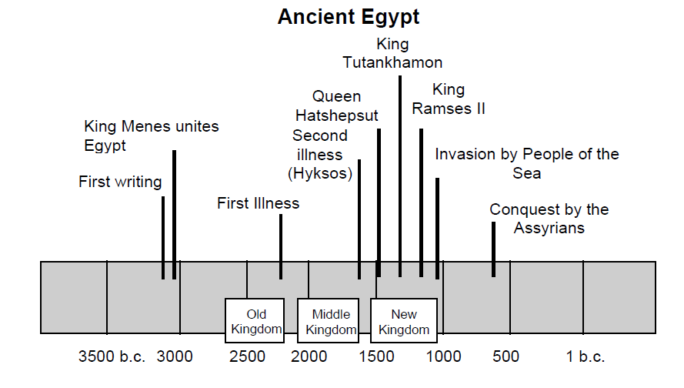
End of Ass
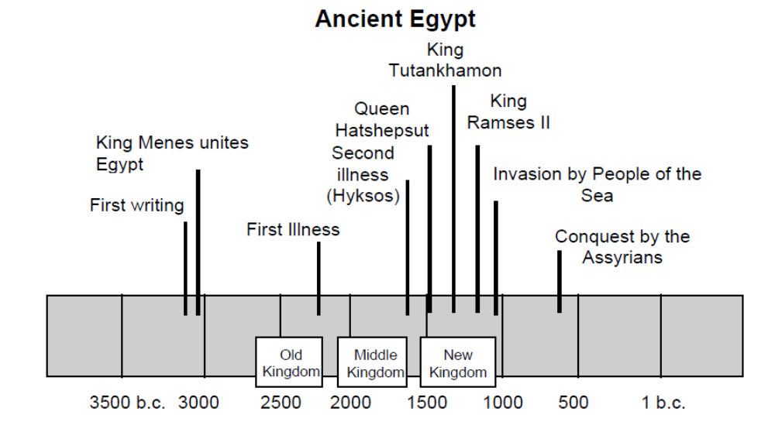
Source 1

